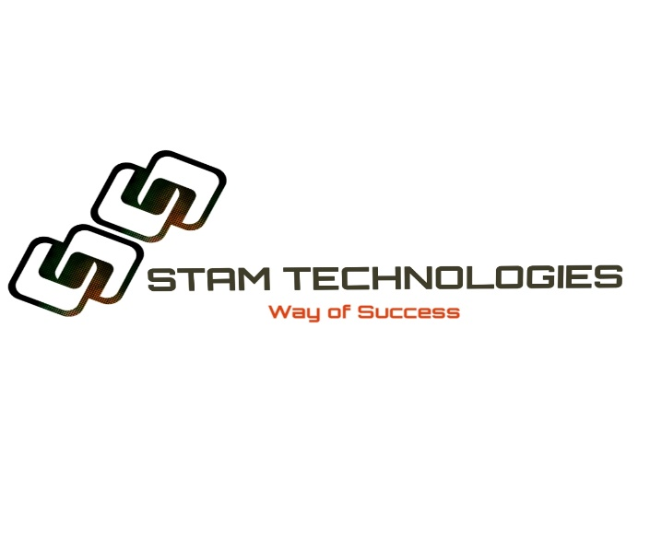

STAM TECHNOLOGIES was incorporated in 2021 by three friends with the vision to provide IT Enabled services in Pakistan and explore new horizons. Till date we have provided the services to our clients abroad. Aim of STAM TECHNOLOGIES is to explore this neglected field of IT and to generate livelihood for themselves and increase exports of the country.